Skill Development and Job Matching Platform Project

**Table of Contents:**

**Chapter 1 Introduction**

**1.1 Introduction 1**

**1.2 Scope 1**

**1.3 Objectives 3**

**1.4 Description 4**

**Chapter 2 System Requirements and analysis**

**2.1 Functional Requirements 5**

**2.2 Non-Functional Requirements 7**

**2.3 Software requirement specifications 9**

**Chapter 3 System Design**

**3.1 Use Case 15**

**3.2 ER Diagram 16**

**3.3 Sequence Diagram 17**

**3.4 Activity Diagram 18**

**3.5 Data Flow Diagram 19**

**3.6 Database Design 20**

**3.7 User Interface Design 21**

**Chapter 4 Results and Discussion**

**4.1 Future Work 24**

**4.2 Enhancements 25**

**4.3 Scalability 26**

**4.4 Conclusion 27**

**4.5 References 28**

**CHAPTER1**

**Introduction:**

The Skill Development and Job Matching Platform is a comprehensive solution designed to bridge the gap between job seekers and employers. It offers skill assessment, personalized learning pathways job matching to help users acquire in-demand skills and connect with suitable job opportunities. For employers, the platform provides valuable insights into candidate competencies, enabling more efficient and accurate hiring decisions. By supporting continuous skill growth and aligning talent with the right roles, the platform aims to enhance career development for individuals and improve recruitment outcomes for organizations.

**Scope:**

**1. Skill Assessment:**

* Provide initial assessments to gauge users’ current skills, strengths, and areas for improvement.
* Integrate with external certification bodies to verify and showcase verified competencies.

**2. Personalized Skill Development:**

* Offer tailored learning paths based on individual career goals, current skills, and industry demands.
* Provide a library of courses, tutorials, and interactive resources covering a variety of in-demand skills.
* Regularly update learning materials to reflect the latest trends and best practices.
* Allow users to set and track learning goals, fostering continuous professional growth.

**3. Job Matching and Recommendation System:**

* Match candidates with job opportunities based on their skills, experience, and career interests.
* Allow employers to create precise job listings with required skills, experiences, and preferred traits for optimal candidate matching.
* Enable job seekers to receive personalized job alerts and recommendations.

**4. Career and Skill Progress Tracking:**

* Provide users with a personal dashboard to track progress in skill development, job applications, and career milestones.
* Offer analytics and insights on career progression, allowing users to measure improvements over time.
* Integrate gamification elements to incentivize learning and keep users engaged.

**5. Employer Tools and Insights:**

* Enable employers to search for candidates based on specific skill sets, experience, and certifications.
* Provide data-driven insights to support hiring decisions and identify the best-fit candidates quickly.
* Offer analytics on the skill gaps within the organization to guide recruitment and training strategies.

**6. Data Security and Compliance:**

* Ensure that all personal data and assessment results are stored securely and comply with data protection regulations.
* Implement privacy and consent protocols for data sharing between candidates and employers.

**Objective:**

1. **Reduce Skills Mismatch in the Job Market:** To bridge the gap between the skills job seekers possess and the specific skills that employers require, by providing targeted upskilling and reskilling opportunities.
2. **Provide Personalized Learning and Development:** To offer tailored learning pathways and career development plans based on individual skill levels, interests, and market demand, ensuring that each user’s training is relevant and effective.
3. **Enhance Employability with Skill Validation:** To enable job seekers to validate and showcase their skills through certifications, assessments, and portfolios, making them more attractive to potential employers.
4. **Streamline Recruitment for Employers:** To provide companies with an intelligent, data-driven recruitment system that helps identify qualified candidates faster, reduces hiring time, and ensures better employee-job fit.
5. **Support Career Transitions:** To assist individuals looking to shift careers by helping them identify transferable skills and providing structured learning programs to acquire new competencies for their desired roles.
6. **Remote and Global Employment Opportunities:** To expand access to job opportunities beyond geographical boundaries by connecting job seekers to remote and global employment options, widening the talent pool for employers.
7. **Improve Workforce Diversity and Inclusion:** To offer equal opportunities for job seekers from various backgrounds and skill levels, helping companies diversify their workforce by reaching candidates from different regions, industries, and skill sets.

**Description:**

The Skill Development and Job Matching Platform is a dynamic solution designed to address the evolving needs of job seekers, professionals, and employers. By integrating personalized learning, skill assessments, and intelligent job matching, the platform empowers users to advance their careers. The platform’s primary goal is to foster a continuous cycle of skill growth and career advancement. It assesses users' current skills and experience, identifies areas for development, and provides targeted training resources. Users can access personalized learning paths, courses, and assessments tailored to in-demand skills in their industry. This helps bridge skill gaps and enhances employability.

Key components of the platform are,

1. **Skill Assessments:** Tools to evaluate current skill levels and identify areas for improvement.
2. **Personalized Learning Paths:** Customizable, industry-specific learning resources that support ongoing skill development.
3. **Progress Tracking:** Dashboards and analytics that allow users to monitor their learning journey and career progress.
4. **Employer Insights:** Tools to help employers find the best candidates, understand talent market trends, and make data-informed hiring decisions.

**CHAPTETR 02**

**Functional Requirements:**

Functional requirements define the specific behaviors or functions of the system. They describe what the system should do and are often expressed in terms of inputs, outputs, and interactions. Here are some functional requirements for a skill development and job matching platform.

**1. User Registration and Authentication:**

**User Registration:** Users (job seekers, employers, training providers) can create accounts with personal details, including name, email, and password.

**Login/Logout:** Users can securely log in and out of their accounts.

Password Recovery: Users can reset their passwords via email verification.

**2. User Profile Management:**

**Profile Creation:** Users can create and manage their profiles, including personal information, education, work experience, skills, and certifications.

**Profile Privacy Settings:** Users can set privacy levels for their profiles (public, private, or limited visibility).

**Profile Updates:** Users can edit and update their profiles as needed.

**3. Skill Assessment and Development:**

**Skill Assessment Tools:** Users can take assessments to evaluate their current skills and competencies.

**Skill Gap Analysis:** The platform identifies gaps in users’ skills based on their career goals and market demands.

**Course Recommendations:** Users receive personalized recommendations for training programs or courses based on their skill gaps and career aspirations.

**4. Job Matching and Search Functionality:**

**Job Search:** Users can search for job openings using various filters (location, industry, job type, salary, etc.).

**Saved Searches and Alerts:** Users can save searches and set up alerts for new job postings that match their criteria.

**5. Employer Features:**

**Employer Registration**: Employers can create accounts to post job openings and manage their company profiles.

**Job Posting:** Employers can post job vacancies with detailed descriptions, requirements, and application instructions.

**Applicant Tracking:** Employers can view and manage applications from job seekers, including reviewing resumes and scheduling interviews.

**6. Communication Tools:**

**Messaging System:** A secure messaging feature allows communication between job seekers and employers.

**Notifications:** Users receive notifications about job matches, application status, messages, and upcoming training sessions.

**7. Training and Development Resources:**

**Training Provider Directory:** Users can browse a list of training providers and their courses.

**Course Enrollment:** Users can enroll in recommended courses directly through the platform.

**Feedback and Reviews:** Users can leave feedback and ratings for courses they have completed.

**8. Analytics and Reporting:**

**User Analytics:** The platform provides users with insights into their profile views, application status, and job market trends.

**Employer Analytics:** Employers can access reports on job postings, applicant demographics, and hiring statistics.

**9. Admin Features:**

**User Management:** Admins can manage user accounts, including verification, suspension, and deletion.

**Content Management:** Admins can manage job postings, training programs, and platform content.

**Reporting and Analytics:** Admins can generate reports on platform usage, user engagement, and overall performance.

**10. Security and Compliance:**

**Data Protection:** The platform must implement security measures to protect user data and privacy.

**Compliance with Regulations:** The platform should comply with relevant data protection regulations.

**Nonfunctional Requirements:**

Non-functional requirements define the quality attributes, system performance, and constraints of a system, rather than the specific behaviors or functions it must perform. For a Skill Development and Job Matching Platform, the following non-functional requirements should be considered:

**1. Performance:**

* Response Time: The platform should provide responses to user actions (e.g., searches, profile updates) within 2 seconds under normal load conditions.
* Throughput: The system should handle a minimum of 500 concurrent users without degradation in performance.

**2. Scalability:**

* Horizontal Scalability: The platform should be able to scale horizontally to accommodate increased user load by adding more servers or resources.
* Load Balancing: The system should distribute incoming user requests evenly across servers to maintain performance during peak usage.

**3. Availability:**

* Uptime: The platform should guarantee 99.9% uptime, ensuring that it is available to users at all times, excluding scheduled maintenance.
* Disaster Recovery: The system should have a disaster recovery plan to restore functionality within 24 hours of a major failure.

**4. Security:**

* Data Encryption: All sensitive user data should be encrypted both in transit and at rest.
* Authentication and Authorization: The platform must implement strong authentication mechanisms and role-based access control to ensure that users can only access resources they are authorized to use.
* Regular Security Audits: The platform should undergo regular security audits and vulnerability assessments to identify and mitigate potential threats.

**5. Usability:**

* User Interface Design: The platform should have an intuitive and user-friendly interface that allows users to navigate easily and complete tasks with minimal effort.
* Accessibility Compliance: The platform should comply with accessibility standards to ensure that it is usable by individuals with disabilities.

**6. Maintainability:**

* Code Quality: The platform should adhere to coding standards and best practices to facilitate easy maintenance and updates.
* Documentation: Comprehensive documentation should be provided for both the codebase and user manuals to assist developers and users.

**Software Requirement Specification(SRS):**

|  |  |
| --- | --- |
| **FR01** | Registration |
| **Description** | To Create profile job seekers and employee need to registration . |
| **Stakeholder** | Job Seekers , Employee , skill Developers |

|  |  |
| --- | --- |
| **FR02** | Log in |
| **Description** | To access their profile job seekers and employee need to login at first. |
| **Stakeholder** | Job Seekers , Employee , skill Developers, Owner |

|  |  |
| --- | --- |
| **FR03** | Create Profile |
| **Description** | job seekers and employee can create their profile. |
| **Stakeholder** | Job Seekers , Employee , skill Developers, |

|  |  |
| --- | --- |
| **FR04** | Update Profile |
| **Description** | Job seekers and employee can update their profile anytime. |
| **Stakeholder** | Job Seekers , Employee  , skill Developers, |

|  |  |
| --- | --- |
| **FR05** | Send Verification OTP |
| **Description** | owner and Job seekers, employees can verify themselves in the system. |
| **Stakeholder** | Job Seekers , Employee , , skill Developers |

|  |  |
| --- | --- |
| **FR06** | Forgot Password |
| **Description** | owner and employees ,Job Seekers can retrieve their profile in the system if they forgot their login password. |
| **Stakeholder** | Job Seekers , Employee , skill Developers |

|  |  |
| --- | --- |
| **FR07** | View Notifications |
| **Description** | Job seekers and employee can view their jobs and posting notifications. |
| **Stakeholder** | Job Seekers , Employee , skill Developers |

|  |  |
| --- | --- |
| **FR08** | Update Notification |
| **Description** | Everyone can customize their notification through update notification |
| **Stakeholder** | Job Seekers , Employee ,skill Developers |

|  |  |
| --- | --- |
| **FR09** | Course Catalog |
| **Description** | User can browse a catalog of available courses categorized by skill type, difficulty level, and duration. |
| **Stakeholder** | skill Developers |

|  |  |
| --- | --- |
| **FR10** | Add Course |
| **Description** | User can add their courses. |
| **Stakeholder** | skill Developers |

|  |  |
| --- | --- |
| **FR11** | Course Enrollment |
| **Description** | Job seekers can enroll their courses |
| **Stakeholder** | Job seeker |

|  |  |
| --- | --- |
| **FR12** | Search for Course |
| **Description** | Job Seekers can search their courses. |
| **Stakeholder** | Job Seekers |

|  |  |
| --- | --- |
| **FR13** | Complete Course |
| **Description** | After completing all the phrase of their course they complete their course |
| **Stakeholder** | Job Seekers |

|  |  |
| --- | --- |
| **FR14** | Issue Certificate |
| **Description** | After completing their course skill developer issue their certificate. |
| **Stakeholder** | skill Developers |

|  |  |
| --- | --- |
| **FR15** | Dashboard |
| **Description** | It will show how work is done by project time. |
| **Stakeholder** | Job Seekers , Employee,  skill Developers |

|  |  |
| --- | --- |
| **FR16** | Search for Jobs |
| **Description** | Job seekers can search their jobs  . |
| **Stakeholder** | Job Seekers |

|  |  |
| --- | --- |
| **FR17** | Apply for jobs |
| **Description** | Job seekers can apply their job |
| **Stakeholder** | Job Seekers |

|  |  |
| --- | --- |
| **FR18** | Job Application |
| **Description** | Job seekers can apply for jobs directly through the portal, attaching their resumes and cover letters. |
| **Stakeholder** | Job Seekers |

|  |  |
| --- | --- |
| **FR19** | Track Applications |
| **Description** | Job seekers can track their jobs |
| **Stakeholder** | Job Seekers |

|  |  |
| --- | --- |
| **FR20** | Create job posting |
| **Description** | Employee can create job post for the job seekers |
| **Stakeholder** | Employee |

|  |  |
| --- | --- |
| **FR21** | Search for Candidates |
| **Description** | Employee are searching their eligible candidate creating job post |
| **Stakeholder** | Employee |

|  |  |
| --- | --- |
| **FR22** | View Candidate profile |
| **Description** | Employee can view their candidate profile |
| **Stakeholder** | Employee |

|  |  |
| --- | --- |
| **FR23** | Interview candidate |
| **Description** | Employee can interview their candidate for their post |
| **Stakeholder** | Employee |

|  |  |
| --- | --- |
| **FR24** | Hire candidates |
| **Description** | Ataking interview. Of candidate employee can hire a candidate |
| **Stakeholder** | Employee |

|  |  |
| --- | --- |
| **FR25** | Manage Platform Content |
| **Description** | An administration can manage the whole platform content |
| **Stakeholder** | Owner |

|  |  |
| --- | --- |
| **FR26** | Manage user Account |
| **Description** | Administration can manage the all users account. |
| **Stakeholder** | Owner |

|  |  |
| --- | --- |
| **FR27** | Maintain platform useage |
| **Description** | Administration  can maintain platform useage |
| **Stakeholder** | Owner |

**CHAPTETR 03**

**Skill Development And Job Matching Platfrom Use Case:**

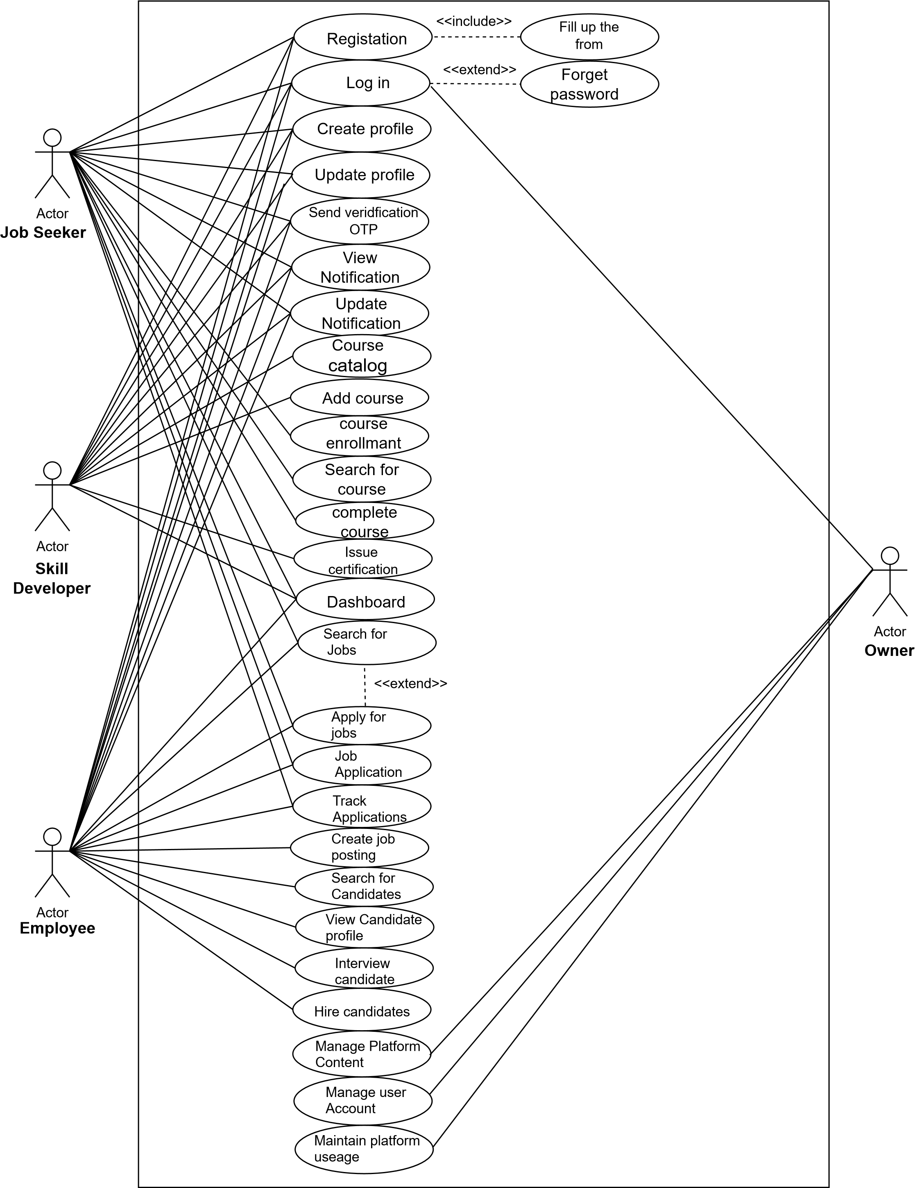

**Figure 1: Use Case**

**Skill Development And Job Matching Platfrom ER Diagram:**

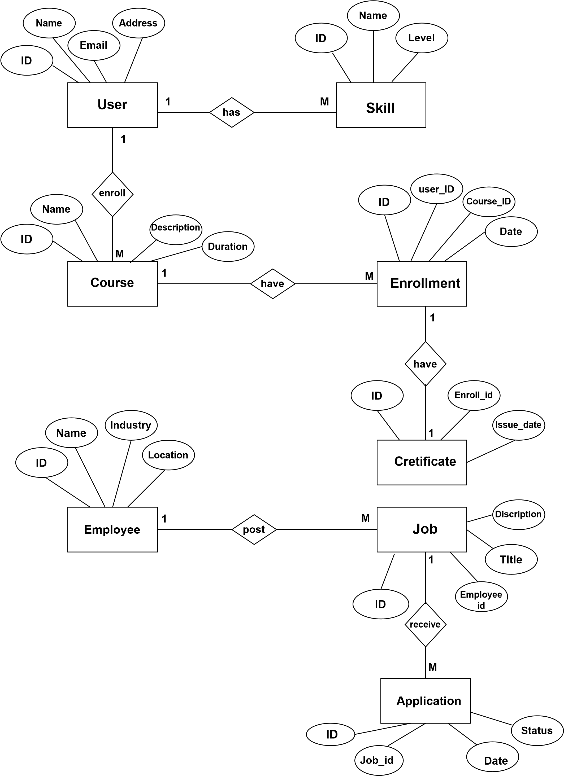

**Figure 2: ER Diagram**

**Skill Development And Job Matching Platfrom Sequence Diagram:**

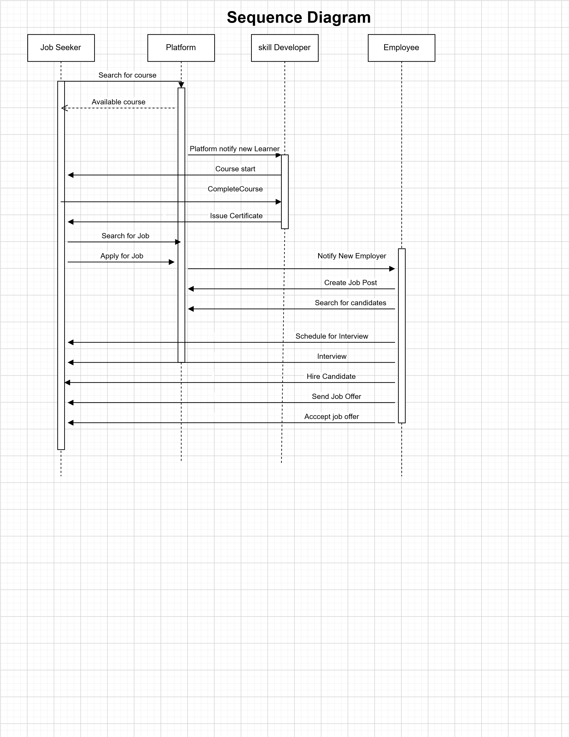

**Figure 3: Sequence Diagram**

**Skill Development And Job Matching Platfrom Activity Diagram:**

**Figure 4: Activity Diagram**



**Job seeker**

Registers on

the platform

Input search

criteria

Decision

skill development

Match

job

Apply for job

Submit application.

Yes

No

submit application.

**Skill Developer's**

Add or update

a course

Review feedback

Adjust courses

as needed

provide

Cretificate

**Employer**

Post a new job

Set required skills

for the job

Shortlist and

schedule interviews

Hire a

candidate

job search

**Owner**

Monitor platform

activity

Manage content

and users

log out the system

**Skill Development And Job Matching Platfrom Dataflow Diagram:**

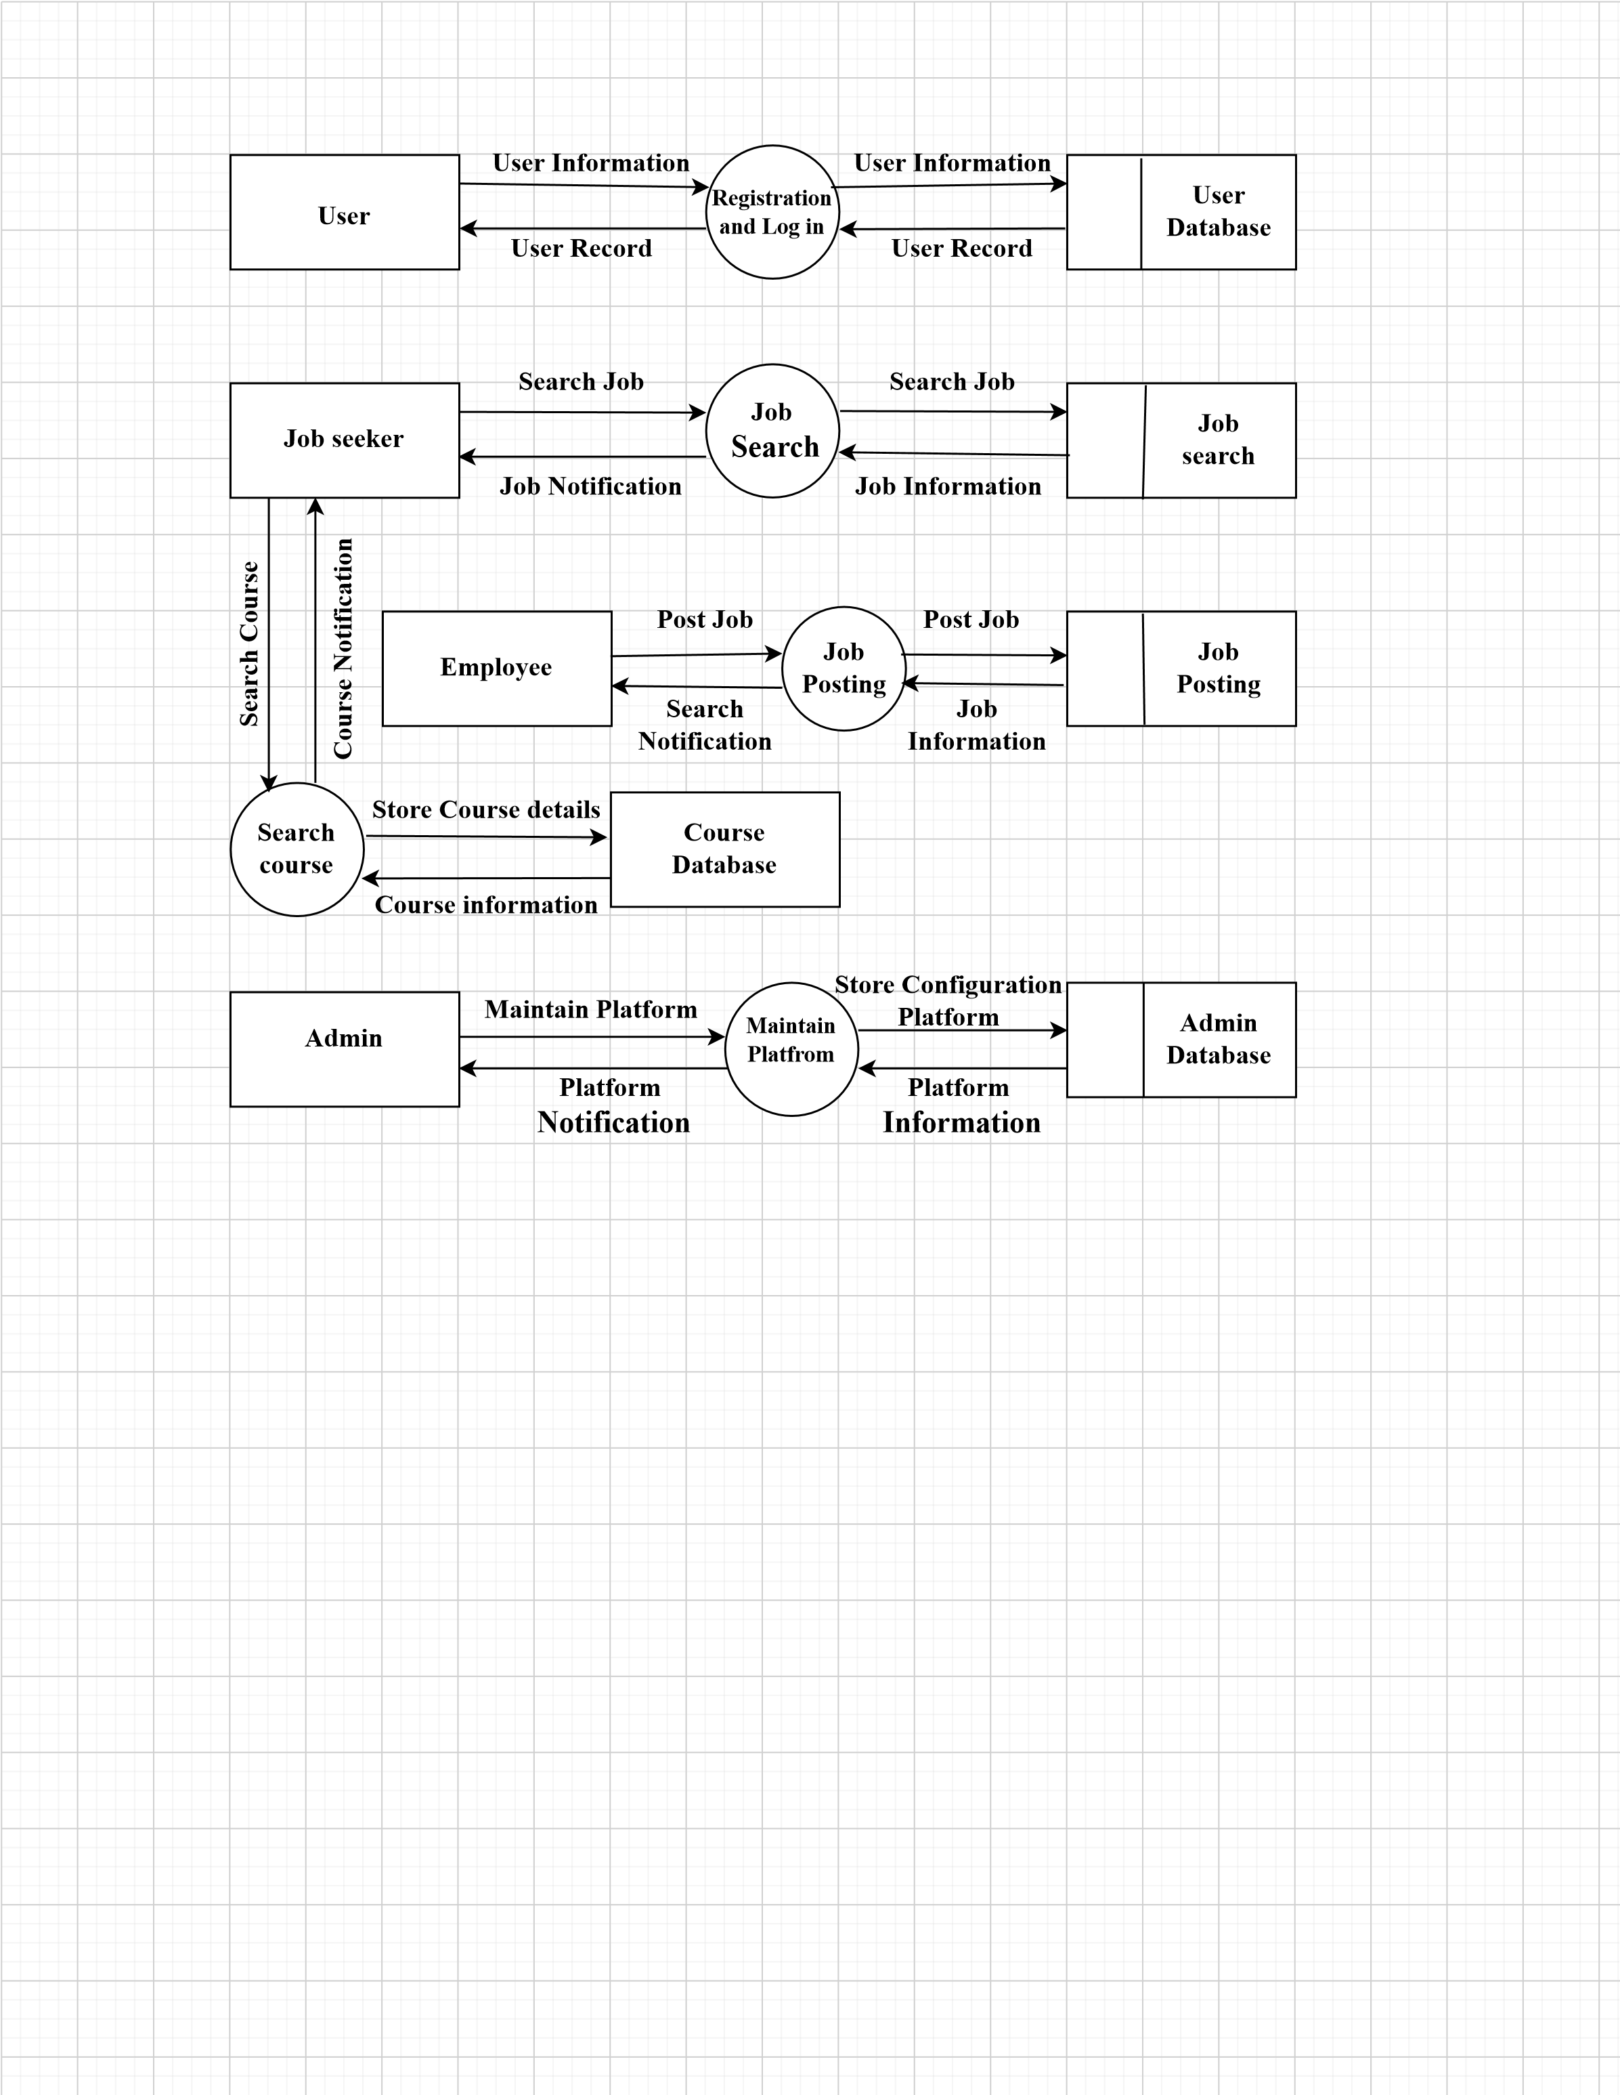

**Figure 5: Data Flow Diagram**

**Database Design:**

**1.User:**

* User ID (Primary Key)
* User Name
* Email
* Address

**2.Skill:**

* Skill ID(Primary Key)
* .Skill Name
* Skill Level

**3.Course:**

* Course ID(Primary Key)
* Course Name
* Course Description
* Course Duration

**4.Enrollment:**

* Enrollment ID(Primary Key)
* Enrollment User ID(Foreign Key)
* Course ID(Foreign Key)
* Date

**5. Employee:**

* employee ID (Primary key)
* employee Name
* Industry
* Location

**Certificate:**

* Certificate ID (Primary key)
* Enroll ID (Foreign key)
* Issue-date

**7. Job:**

* Job ID (Primary key)
* Employee ID (Foreign vey)
* Job Title
* Job Description

**8 Application**

* Application ID (Primary key)
* Job-ID (Foreign key)
* Date
* Status

**User Interface Design:**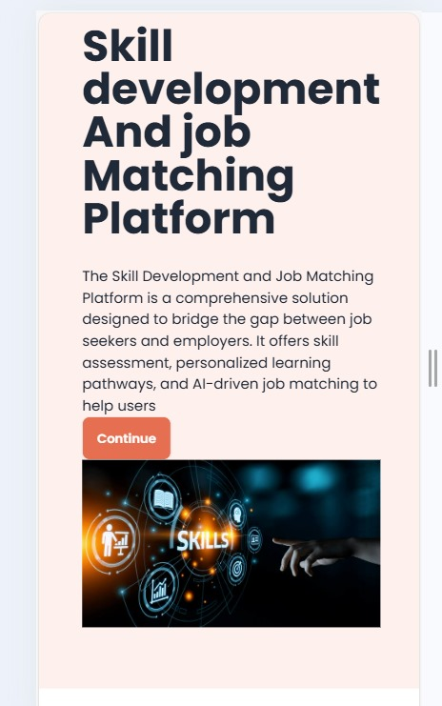

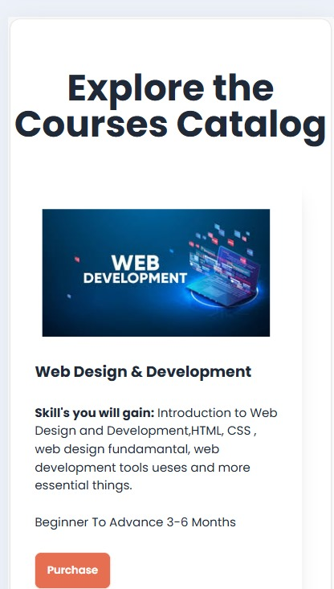

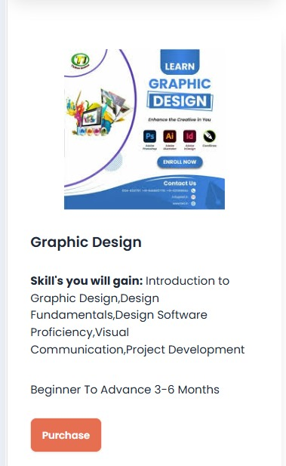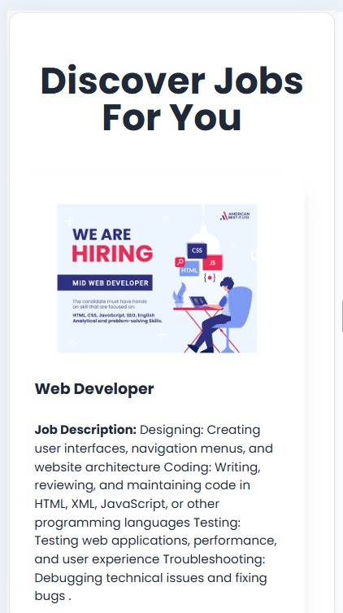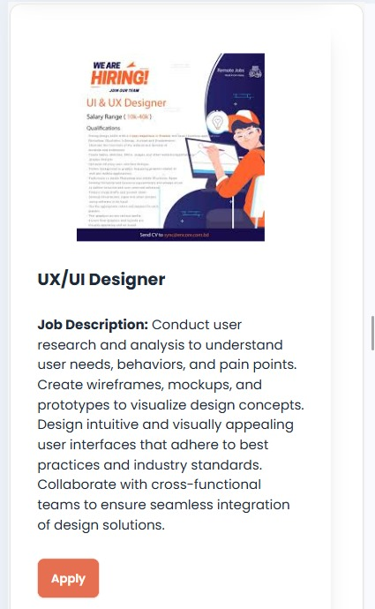

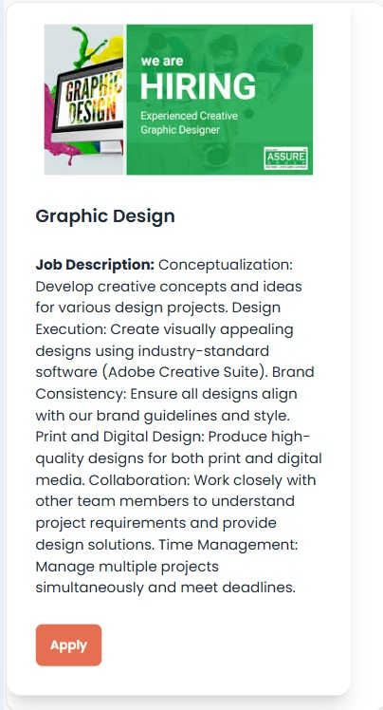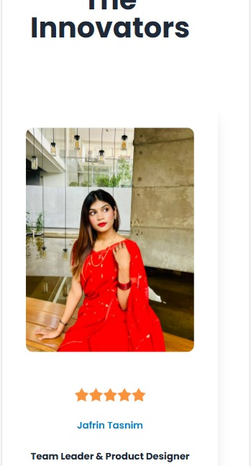

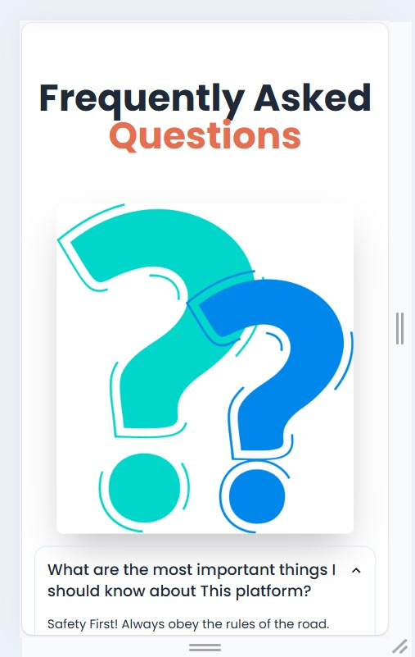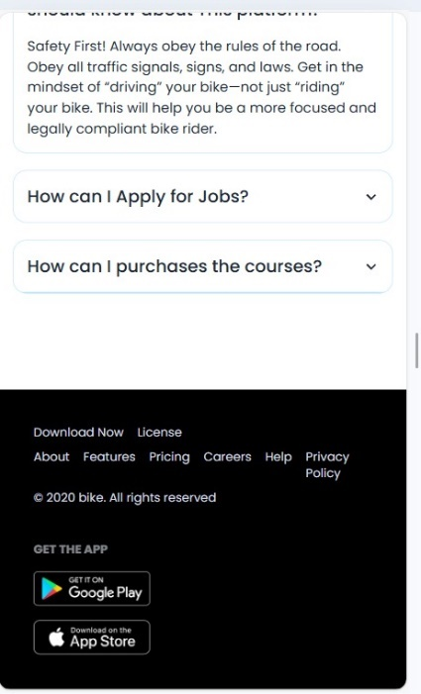

**CHAPTETR 04**

**Future Work:**

To stay relevant in a rapidly changing job market and continuously meet user needs, the Skill Development and Job Matching Platform can focus on several future enhancements. These improvements aim to increase platform effectiveness, enhance user engagement, and expand the range of services provided.

**1. Enhanced AI and Machine Learning Capabilities:**

* Advanced Job Matching Algorithms: Continuously refine AI algorithms to provide more accurate job recommendations by incorporating deeper learning from user interactions, feedback, and career progression.
* Predictive Analytics for Skill Development: Use predictive models to recommend future skills based on career trajectory, industry trends, and emerging market demands.

**2. Virtual Reality (VR) and Augmented Reality (AR) for Skill Training:**

* Integrate VR and AR technologies to offer immersive, hands-on training experiences for high-skill and technical jobs (e.g., machinery operation, healthcare procedures).
* Enable virtual simulations for real-world scenarios, allowing users to practice skills and gain experience in a controlled environment.

**3. Expanded Soft Skills Training and Assessment:**

* Offer courses and assessments focused on soft skills (e.g., communication, leadership, teamwork) to address the growing demand for these skills across industries.
* Use role-playing simulations, case studies, and real-time feedback to help users build soft skills alongside technical competencies.

**4.Integration with External Learning Platforms and Job Boards:**

* Integrate with popular external learning platforms (e.g., Coursera, Udemy) to expand the range of courses and certifications available.
* Partner with job boards and professional networks to increase job listings and provide users with a more extensive selection of employment opportunities.

**5. Advanced Analytics for Users and Employers:**

* Provide users with deeper analytics on their career growth, benchmarking their progress against peers in the same field.
* Offer employers comprehensive analytics on candidate performance, job success rates, and emerging skill trends, allowing for data-driven hiring and training decisions.

**6. Global Expansion and Multilingual Support:**

* Expand to support multiple languages and local job markets to make the platform accessible to a more diverse, global user base.
* Develop region-specific job matching algorithms to better serve international users and accommodate local hiring trends.

**Enhancements:**

**1. Mobile App Development:**

* Accessibility and Convenience: A mobile app allows users to access the platform on the go, increasing engagement and accessibility.
* Push Notifications: Notify users of relevant job openings, skill development opportunities, interview schedules, and updates.

**2. Integration with Skill Records and Portfolios:**

* Automated Skill Tracking: Integrate with credential platforms, course providers, and certifications to update users’ profiles automatically as they complete skills or courses.
* Portfolio Showcase: Enable users to upload project files, code samples, case studies, and portfolios, showcasing skills directly on their profiles.

**3. Enhanced Job Matching Algorithms:**

* Skill-Based Matching: Focus on matching jobs not only based on keywords but also on specific skills, certification levels, and relevant project experience.
* Culture and Values Matching: Introduce questionnaires that assess users’ preferences for company culture and values, aligning them with compatible employers.

**4. Advanced Data Analytics for User Insights:**

* Career Progress Tracking: Show users how their skills and experience levels have evolved over time and what impact this has had on job matches.
* Skill Demand Trends: Inform users of emerging skills in their industry and provide insights on which skills are rising in demand.
* Personalized Job Analytics: Allow users to view statistics on job applications, such as response rates, match quality, and areas for improvement.

**Scalability:**

1. **Cloud Infrastructure & Microservices:** Use cloud providers and a microservices architecture to scale resources dynamically, improving reliability and performance.
2. **Efficient Data Management:** Use distributed databases, caching, and data partitioning to manage large volumes and ensure quick access.
3. **Optimized Matching Algorithms**: Enhance algorithms for faster processing, and deploy machine learning models that can handle high loads efficiently.
4. **Security & Compliance**: Ensure robust security, privacy, and compliance practices to protect user data as the platform scales.

**Conclusion:**

A skill development and job-matching platform plays a crucial role in bridging the gap between job seekers and employers by aligning skills with job requirements in a constantly evolving market. By integrating advanced matching algorithms, scalable infrastructure, and personalized learning pathways, the platform can provide tailored career guidance, boost employability, and streamline hiring for companies.

**References:**

1. ES Krendal, DT McRuer , *The Study of Movement Skill Development Strategies.*

2. RN Lussier, CF Achua-2022 " Leadership: *Theory. Application &Skill Development.*

3.JA Waters-*Academy of Management* *Review,*1980*-jounals.aom.org* *“Managerial skill Development”*